2-echelon

Documentation

Author(s): Beatriz Royo

Author’(s’) affiliation (Partner short name): ZLC

Revision History

|  |  |  |
| --- | --- | --- |
| Version No. | Date | Details |
| 1.0 | 25.11.2021 | First version of the document. |
|  |  |  |
|  |  |  |
|  |  |  |
|  |  |  |

Contents

1 Introduction 4

1.1 Scope and objectives 4

2 Requirements. 6

2.1 Software requirements 6

2.2 Input/Outputs 6

2.2.1 Inputs 6

2.2.2 Outputs 7

2.3 Paths structure 7

3 Model Description 8

4 Instructions to run the model 9

4.1 Command line execution of the model 9

4.1.1 Instructions and commands 9

4.1.2 Arguments 10

4.2 Requirements 10

4.2.1 Testing requirements 10

4.2.2 Folder1 11

4.2.3 Folder2 11

List of tables

Table 1 2-echelon model – Inputs 6

# Introduction

## Scope and objectives

The -ecommerce growth has increased the transport flows in the cities while policymakers are introducing delivery constraints with the creation of low emissions zones or low traffic zones that banned the access to fossil fuel or high size vehicles. This panorama is forcing last mile sector to shift from the business as usual (BAU) scenario or 1-echelon (Figure 1 – left) to 2-echelon networks (Figure 1 – right).

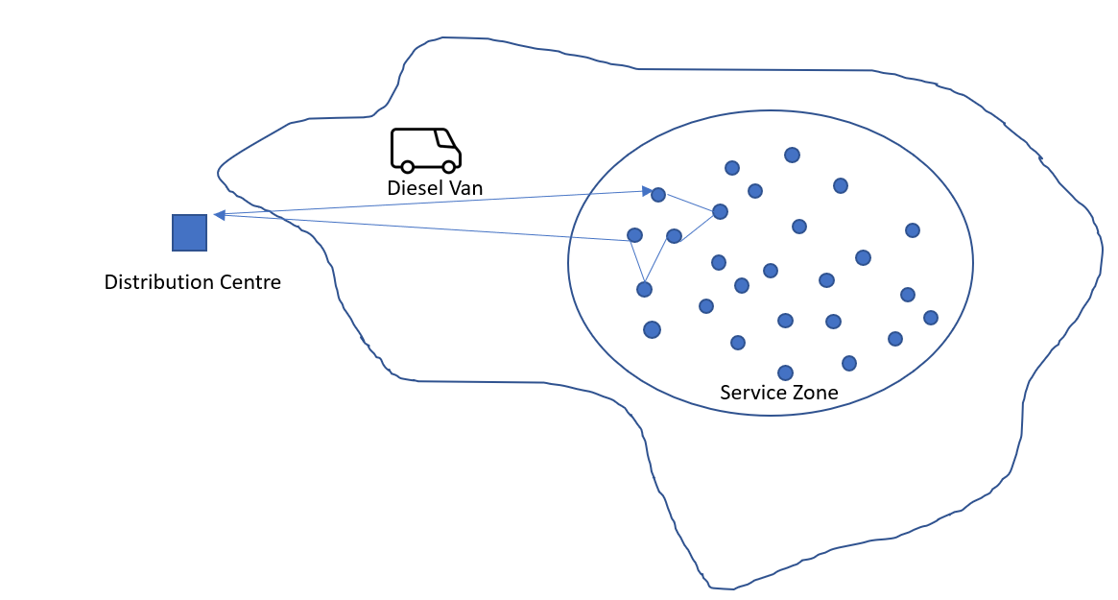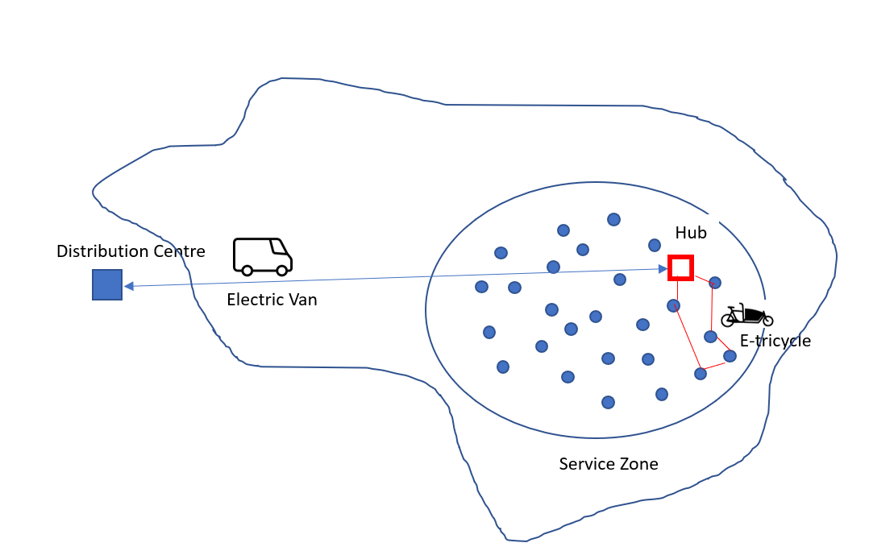

Figure 1. 1-Echelon vs 2- Echelon last-mile distribution networks.

The objective of this model is to support the last-mile sector to compare the impacts of different configuration networks with minimums levels of data granularity. Based on the results (number of vehicles, distances and time) the user can calculate the environmental, operational and financial impact and easily respond to a wide list of “what if” scenarios such as:

* “*what if I move from 1-echelon network using Diesel vans to a 1-echelon using electric vans?”*
* “*what if I move from 1-echelon network using Diesel vans to a 2-echelon using electric vans and e-trikes?”*
* “*what if I install the hub within the city in another location?”*
* *“what if the demand changes”?*
* *….*

Regardless of the scenario, we assume a single distribution Centre (origin) where products are demanded at many destinations within a specified service zone, using a unique type of vehicle with known capacity and within a specific time. We assume all the nodes within the service zone are delivery points.

For estimating the resources needed, the distances and the delivery time per type of vehicle, the following assumptions are required according to the scenario.

1-echelon:

For this scenario (Figure 1 – left) there is only a distribution Centre to serve to the specified service zone. It uses only one type of vehicle “i” with a known capacity. Handling time in the distribution Centre is constant*.*

**Single Distribution Centre**

* Surrounding the city boundaries
* Products are demanded at many destinations
* All destinations within specified service zone
* Hanldling time is considered

**Assumptions**

* 1 echelon network
* Vehicles are homogenous
* Same Capacity
* Workshift constant
* Handling time is constant

2-echelon:

For this scenario (Figure 1 – right), there is a distribution Centre and a hub to serve to the specified service zone. The hub is cross-dock facility where the goods are moved from one vehicle of type “i” supplying the hub from the distribution Centre with direct shipments to another vehicle of type “j” distributing from the hub to the service zone with multiple delivery points. Vehicle type “i” is different to vehicle type “j”. Vehicles type “i" and “j” are known and constant. Handling time in the distribution Centre is constant and handling time in the hub is zero. In the hub we assume the shift time is included in the stop time of vehicle of type “i”. The workshift of the driver of vehicle of type “i” is independent of vehicle type “j” driver’s workshift.

**Single Distribution Centre**

* Surrounding the city boundaries
* Products are for the hub
* All destinations to the hub
* Handling time is considered

**Single crossdock**

* Products from one origin
* Products are demanded at many destinations
* All destinations within specified service zone
* Handling time not considered

**Assumptions**

* 2 echelon network
* Vehicles for 1st leg are homogenous
* Vehicles for 2nd leg are homogenous
* 1st leg and 2ng leg vehicles capacities and characteristics are known
* 1st leg and 2ng leg vehicles are different
* 1st leg and 2ng leg constant and independent
* Handling time for the DC is constant
* Handling time for the hub is zero, shift time include in the stop time of the 1st leg

# Requirements.

## Software requirements

The language and the software version for running the model is shown in Figure 2.:

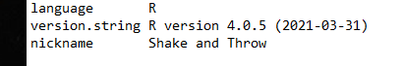

Figure 2. Model version of the language and software.

The following libraries are needed for obtaining the area and centroid of the area of the shapefile with the boundaries of the service area (optional).

* geojosonio package in R ([Cran](https://cran.r-project.org/web/packages/geojsonio/index.html), [github](https://github.com/ropensci/geojsonio))
* sf package in R ([Cran](https://cran.r-project.org/web/packages/sf/index.html) [github](https://github.com/r-spatial/sf)),

## Input/Outputs

### Inputs

The 2-echelon model has the following inputs and its outputs.

Table 1 2-echelon model – Inputs

|  |  |
| --- | --- |
| Inputs | Description |
| facilitesASIS.csv | Table with the characteristics of the distribution centre outside the city boundaries. For executing the 1-echelon network. |
| facilitesTOBE.csv | Table with the characteristics of the distribution centre outside the city boundaries and the hub within the service zone. For executing the 2-echelon network. |
| vehiclesASIS.csv | Table with the characteristics of the vehicle that supplies final consumers within the city boundaries from the distribution centre. For executing the 1-echelon network. |
| vehiclesTOBE.csv | Table with the characteristics of the vehicle that supplies the hub from the distribution centre to the hub within the service zone and the characteristics of the vehicle that delivers the final consumers within the city boundaries from the hub. For executing the 2-echelon network. |
| services.csv | Table with the with the list of orders to deliver within the delivery or service zone. The same file for 1-echelon and 2-echelon networks. |
| Config.csv | Configuration file with some parameters and default values. The same file for 1-echelon and 2-echelon networks |
| serviceZone.shp | Shapefiles with the service zone polygon or boundaries. The same file for 1-echelon and 2-echelon networks. |

### Outputs

Table 2. 2-echelon model – Outputs

|  |  |
| --- | --- |
| Outputs | Description |
| testOutputASIS.txt | File with the number of vehicles, distance and time for the executing the 1-echelon network. |
| testOutputTOBE.txt | File with the number of vehicles, distance and time for the executing the 2-echelon network. |

## Paths structure

The structure of the folder for running the 2-echelon model for the 1-echelon and 2-echelon networks is presented in with an example of the city of Madrid in Spain.

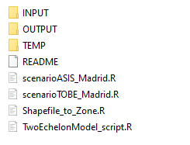

Figure 3. 2-Echelon directory structure.

The INPUT folder contains the files for running the AS IS and to TO BE scenarios. More specifically, it contains the following files:

* facilitiesASIS.csv, facilitiesTOBE.csv
* vehiclesASIS.csv, vehiclesTOBE.csv
* services.csv
* config.csv

The TEMP folder contains the input with the geographic data of the service zone.

* Madrid_Central.shp, Madrid_Central.dbf, Madrid_Central.prj, Madrid_Central.qpj, Madrid_Central.shx

The OUTPUT folder contains the results of running the AS IS and TO BE scenarios. More specifically, it contains the following files:

* testOutputASIS.txt, testOutputTOBE.txt

The scripts for running the scenarios of Madrid are explained in the following section.

# Model Description

This section describes the different files and scripts present in the model

|  |  |  |
| --- | --- | --- |
| File name | Location | Description |
| Shapefile_to_Zone.r | Root folder | Functions for reading geographic data |
| TwoEchelonModel_script.r | Root folder | Functions for calculating the number of vehicles, distance and times  for delivering for one leg (ASIS) and two legs (TOBE) scenarios. |
| scenarioASIS_Madrid.r | Root folder | Script for executing the scenario ASIS and writing the results in a specific document.  The information required is in the INPUT folder and the output will be saved in the OUTPUT folder. |
| scenarioTOBE_Madrid.r | Root folder | Script for executing the scenario TOBE and writing the results in a specific document.  The information required is in the INPUT folder and the output will be saved in the OUTPUT folder. (NOT WORKING) |

# Instructions to run the model

## Command line execution of the model

### Instructions and commands

* Commands for preparing the libraries and check versions

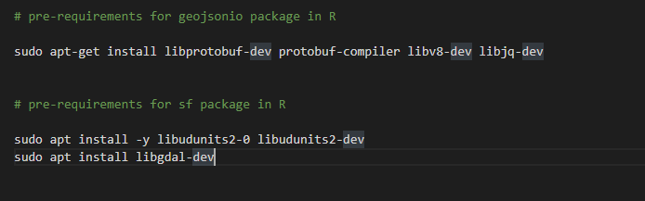

Figure 4. Pre-requirements.

* Commands to actually run the model

Rscript ~/Documents/zlc_models/2ECHELON/scenarioASIS_Madrid.R ~/Documents/zlc_models/2ECHELON/INPUT/config.csv ~/Documents/zlc_models/2ECHELON/INPUT/services.csv ~/Documents/zlc_models/2ECHELON/INPUT/facilitiesASIS.csv ~/Documents/zlc_models/2ECHELON/INPUT/vehiclesASIS.csv ~/Documents/zlc_models/2ECHELON

### Arguments

Identification of the arguments in the command line are described below:

args[1] = csv with the config parameters "U:/2ECHELON/INPUT/config.csv"; the file in the INPUT FOLDER

args[2] = csv with the daily services from the operator "U:/2ECHELON/INPUT/services.csv"; see file in the INPUT FOLDER

args[3] = csv with the daily facilities "U:/2ECHELON/INPUT/facilitiesASIS.csv"; see file in the INPUT FOLDER

args[4] = csv with the daily vehicles "U:/2ECHELON/INPUT/vehiclesASIS.csv"; see file in the INPUT FOLDER

args[5] = working directory "U:/2ECHELON"; to create the TEMP folder and the OUTPUT of the model concrete information about the inputs and outputs

## Requirements

### Testing requirements

# System requirements for rjava R library

sudo apt-get install -y default-jre

sudo apt-get install -y default-jdk

sudo R CMD javareconf

# pre-requirements for geojsonio package in R

sudo apt-get install libprotobuf-dev protobuf-compiler libv8-dev libjq-dev

# pre-requirements for sf package in R

sudo apt install -y libudunits2-0 libudunits2-dev

sudo apt install libgdal-dev

### Folder INPUT

The inputs of the model see Table 1.

### Folder OUTPUT

The outputs of the model see Table 2.

### Folder TEMP

Optional folder to unzip the geographic data of the model if available in an open repository as in the case of the example. The content below is after downloading and unzipping the information of the Low Emissions Zone (LEZ) in Madrid from the open repository.

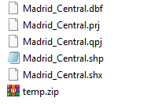

Figure 5. Content of Optional Folder (TEMP) from the open repository of the LEZ of Madrid